OPERATING SYSTEMS PROGRAMMING TASK - 2
AI-Assisted Synchronization Algorithms with Program-Generated HTML Simulation
Readers-Writers Problem and Dining Philosophers Problem
(Semaphore-based and Monitor-based Implementations in Python)

SUBMITTED BY
Name: Greeshma
USN: NNM24IS087
Course: Operating Systems Fundamentals
GitHub Repository: https://github.com/Greeshma-kulal/OS-Task-2/tree/main

SUBMITTED TO
Dr Jason Elroy Martis
Associate Professor
Department of Information Science and Engineering
NMAM Institute of Technology, Nitte

Contents
1. Problem statement and Objectives 3
1.1 Objectives 3
2. Readers -Writers Problem: 4
2.1 Semaphore-Based Solution 4
Shared resource and participants 4
Synchronization variables 4
Working of the Solution 4
Fairness problem 4
2.2 Monitor-Based Solution 4
Monitor Abstraction 4
Entry conditions 4
Fairness consideration 4
3. Dining Philosophers Problem: 4
3.1 Semaphore-Based Solution 4
Problem setup 4
Variables used for synchronization 4
Deadlock prevention 4
3.2 Monitor-Based Solution 4
Monitor State 4
Working of the Solution 4
Deadlock and Starvation 4
Deadlock prevention 4
3.2 Monitor-Based Solution 5
Monitor State 5
Working of the Solution 5
Deadlock and Starvation 5
4. Execution Monitoring and HTML visualization 5
Generated HTML files: 6
5. Results and Observations 6
5.1 Execution trace Summaries 6
5.1.1 Readers-Writers Using Semaphores 6
5.1.2 Readers-Writers using a Monitor 7
5.1.3 Dining Philosophers using Semaphores 8
5.1.4 Dining Philosophers using a Monitor 9
6. Analysis of Synchronization Methods 11
6.1 Race condition 11
6.2 Mutual exclusion 11
6.3 Deadlock 11
6.4 Starvation 11
6.5 Concurrency and repeatability 11
7. Comparative Analysis of Synchronization Methods 12
8. Conclusion and Future Scope 13
9. AI Assistance and Development Record 13
9.1 Prompts and changes to document 13
9.1.1 Initial prompts 13
9.1.2 Follow-up prompts 14
9.1.3. Student Modifications 14
10. References 14
11. Academic-Integrity Declaration 15

Problem statement and Objectives
When several threads access the same data or resources simultaneously, it is necessary to apply correct synchronization to avoid potential conflicts. For instance, the writer should not change the shared data when readers read it. Moreover, in certain cases, threads will wait for the resources owned by each other, and that will result in deadlock. In this regard, synchronization can help to manage the described situations.
In this assignment, two typical operating system problems, namely Readers-Writers and Dining Philosophers, are implemented with semaphores and monitor-based synchronization in Python. For both problems, there are two implementations provided: one with semaphores and one with monitor synchronization. It is important to note that in the current project, events that happen during the program run are logged and used for creating HTML animation.

1.1 Objectives
Demonstrate synchronization using Python threads that run simultaneously.
Semaphores, locks, and condition variables to protect shared data and resources.
How mutual exclusion and safe concurrency can be attained.
Deadlock prevention and the likelihood of starvation.
Logging of actual events in the program and creation of HTML pages for playback of those events.

Readers -Writers Problem:

2.1 Semaphore-Based Solution

Shared resource and participants
The program makes use of an integer variable known as shared_value as the shared data. There are three reader threads (R1-R3) and two writer threads (W1-W2). Each thread does two cycles. Readers look at the current value, writers increase it.

Synchronization variables
reader_count - counts the number of readers currently present in the reading area.
reader_count_lock - semaphore, initialized to 1, used for changes of reader_count.
resource_lock - semaphore, initialized to 1, which prevents access to the shared resource by writers while readers are working and prevents several writers from writing at the same time.

Working of the Solution
First, a reader takes reader_count_lock and increases reader_count. The first reader takes resource_lock, which prevents writers from entering. After that, it releases reader_count_lock and reads the value of the shared resource. Then it decreases reader_count under reader_count_lock. The last reader releases resource_lock.
Writer takes resource_lock and updates shared_value. It reads the previous value of shared resource, increases it and logs the new value. Therefore, several readers can read at once, but one writer uses the shared resource.

Fairness problem
This is a solution based on preferences of the readers. It does not guarantee first-in-first-out policy. The writer can be waiting for the readers for a very long period of time. This problem of starvation must be separated from mutual exclusion.

2.2 Monitor-Based Solution

Monitor Abstraction
Python does not provide a dedicated monitor keyword, so the implementation uses threading.Condition as a monitor-style abstraction. The condition protects active_readers, active_writer, waiting_writers, and the shared value.

Entry conditions
A reader waits while a writer is active or any writer is waiting.
A writer increments waiting_writers and waits while another writer is active or readers are active.
The writer marks active_writer as true before updating shared_value, then marks it false when finished.
When a writer finishes, or when the last reader leaves, condition.notify_all() wakes waiting threads so they can check their conditions again.
The waiting conditions are checked in while loops. A thread must re-check the condition after waking because another thread may have changed the shared state before it reacquires the lock.

Fairness consideration
The monitor implementation gives priority to waiting writers by preventing new readers from entering while waiting_writers is greater than zero. This reduces the risk of writer starvation, although strict FIFO scheduling is not implemented and readers may wait while writers continue to arrive.

Dining Philosophers Problem:

3.1 Semaphore-Based Solution

Problem setup
The simulation has precisely four philosophers (P1-P4) and four forks (F1-F4). Each philosopher cycles between thinking, feeling hungry, getting the forks, eating, and then putting down the forks.

Variables used for synchronization
Semaphore of value 1 associated with each fork, which ensures that at most one philosopher holds that particular fork.
Semaphore of value 3 associated with the room. Only three philosophers can get into contention for forks simultaneously.
Lock associated with fork owner data to protect the event logger.

Deadlock prevention
The room semaphore guarantees that none of the four philosophers will be in the fork acquisition phase at the same time. Thus, the circular wait condition where each philosopher has one fork but is waiting for another is violated. Philosophers acquire the fork semaphores of the neighbors, eat, release the forks, and finally release the room permit.
This scheme of using semaphores guarantees that deadlock will not occur according to this particular configuration. However, Python semaphores do not ensure FIFO order guarantee, therefore starvation cannot be excluded. Short delays are introduced to show thread interleavings.

3.2 Monitor-Based Solution

Monitor State
In the monitor approach, a threading.Condition object and an eating list containing one Boolean element for each philosopher are used. This list maintains the information about the current status of eating for each philosopher. An owners list contains information about the philosopher who owns each fork for the HTML tracing.

Working of the Solution
Each philosopher gets hungry and proceeds to the condition-protected part. The philosopher ensures that none of the neighbors are eating before eating. This is checked using a while loop. The philosopher waits on the condition object if any of the neighbors is eating. Otherwise, it marks itself as eating and saves the owners of the two forks.
After the time spent on eating is elapsed, the philosopher acquires the condition once again, marks itself as not eating, removes its fork ownership and performs notify_all() call.

Deadlock and Starvation
Both forks are allocated at the same time when the lock is active. Thus, a philosopher never holds one fork while waiting for another one, and the “hold and wait” situation, which causes the deadlock, cannot happen. There is no FIFO rule for philosophers, and a philosopher can be delayed by adjacent philosophers many times.

Deadlock prevention
The room semaphore guarantees that none of the four philosophers will be in the fork acquisition phase at the same time. Thus, the circular wait condition where each philosopher has one fork but is waiting for another is violated. Philosophers acquire the fork semaphores of the neighbors, eat, release the forks, and finally release the room permit.
This scheme of using semaphores guarantees that deadlock will not occur according to this particular configuration. However, Python semaphores do not ensure FIFO order guarantee, therefore starvation cannot be excluded. Short delays are introduced to show thread interleavings.

3.2 Monitor-Based Solution

Monitor State
In the monitor approach, a threading.Condition object and an eating list containing one Boolean element for each philosopher are used. This list maintains the information about the current status of eating for each philosopher. An owners list contains information about the philosopher who owns each fork for the HTML tracing.

Working of the Solution
Each philosopher gets hungry and proceeds to the condition-protected part. The philosopher ensures that none of the neighbors are eating before eating. This is checked using a while loop. The philosopher waits on the condition object if any of the neighbors is eating. Otherwise, it marks itself as eating and saves the owners of the two forks.
After the time spent on eating is elapsed, the philosopher acquires the condition once again, marks itself as not eating, removes its fork ownership and performs notify_all() call.

Deadlock and Starvation
Both forks are allocated at the same time when the lock is active. Thus, a philosopher never holds one fork while waiting for another one, and the “hold and wait” situation, which causes the deadlock, cannot happen. There is no FIFO rule for philosophers, and a philosopher can be delayed by adjacent philosophers many times.

Execution Monitoring and HTML visualization
All four implementations utilize one helper that records the essential events during the program execution. Every event stores the relative time stamp, identifier of the actor, its state at the moment of the event and a small message describing the event. In case of Readers-Writers problem, the shared value may also be included into the event while in Dining Philosophers problem the information about fork ownership.
After all the worker threads finish their execution, the collected events are stored and are used to create the standalone HTML file in the generated_html directory. The HTML page shows the state of threads, the timeline of events and a progress slider. Additionally, the HTML page provides Play, Pause, Reset and playback speed controls to enable the analysis of the program execution step-by-step.
The HTML animation reproduces the events captured during the execution of the Python program. The HTML animation does not affect the work of Python threads. To capture the events of the next execution trace, it is necessary to run the Python program once again and open the created HTML file in a browser.

Generated HTML files:
For each of the implementations, the following HTML files are generated by the project:
generated_html/readers_writers_semaphore.html
generated_html/readers_writers_monitor.html
generated_html/dining_philosophers_semaphore.html
generated_html/dining_philosophers_monitor.html

Results and Observations
All four pieces of code have been designed to show the events with their timestamps in the console and create the animation in HTML as well. Since the scheduling of threads and delays used is different each time, the events may appear in a different order in each run. The observations presented below depict what behavior is expected and should be cross-checked with the screenshots obtained from running the code.

5.1 Execution trace Summaries

5.1.1 Readers-Writers Using Semaphores
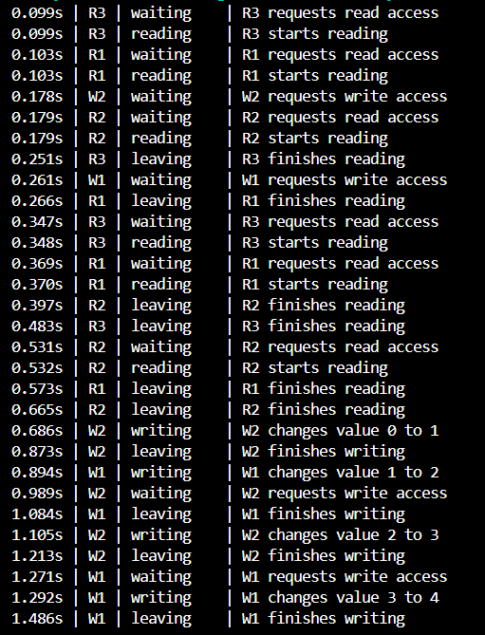
The execution trace shows readers entering and leaving the reading section and writers waiting for exclusive access to the shared resource. When a writer gets access, it updates the shared integer. Multiple readers can read at the same time, but writers update the value one at a time without interfering with active readers.

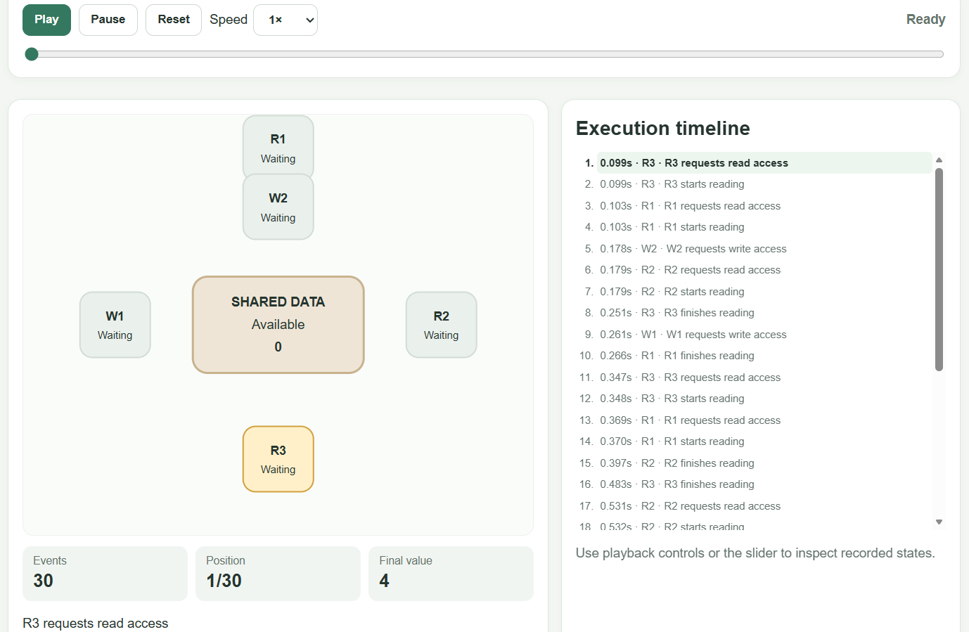

5.1.2 Readers-Writers using a Monitor
This diagram depicts readers and writers that wait under certain conditions as specified in the monitor. The writers get exclusive access to the shared resource while writing on it. Once the writers and readers complete their work, the notification process wakes up threads to verify the entry conditions.
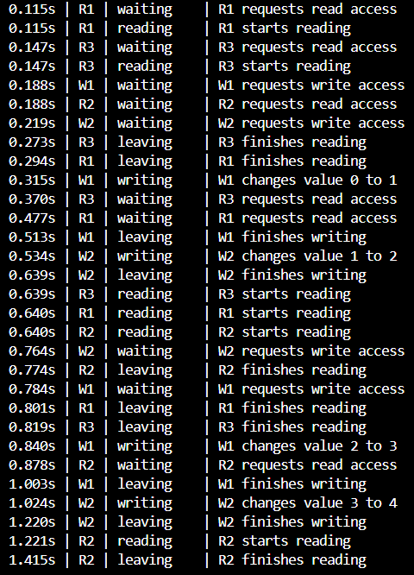
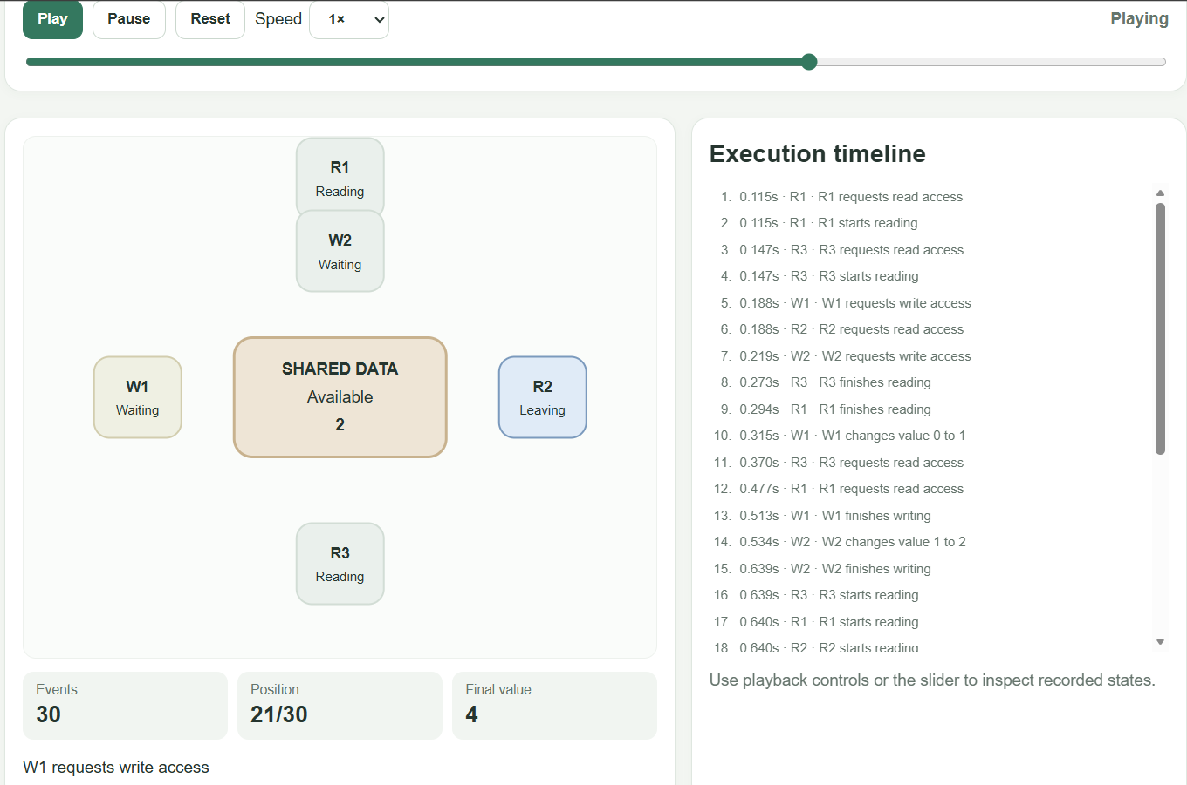

5.1.3 Dining Philosophers using Semaphores
In this trace, the philosophers get hungry, take their forks, eat, and put down their forks. The room semaphore ensures that not too many philosophers will compete for the forks at one time, thus reducing deadlock.

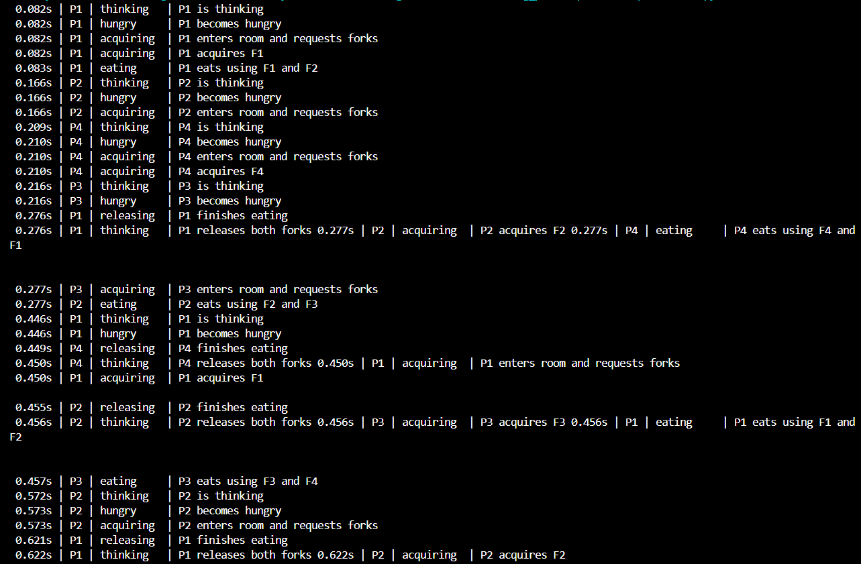

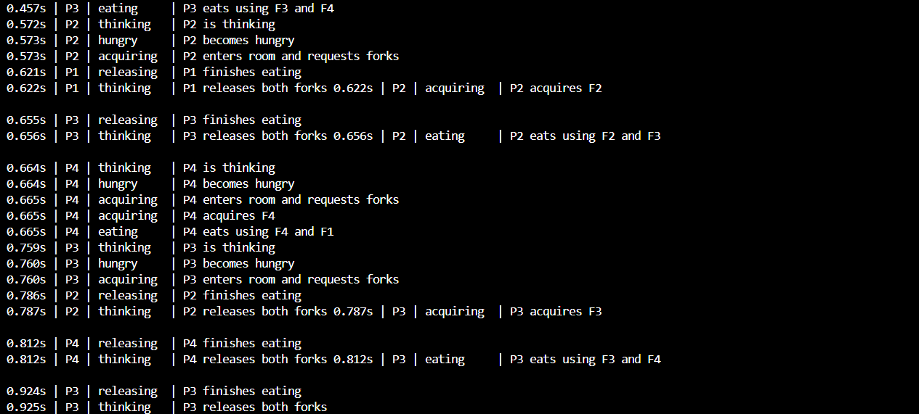

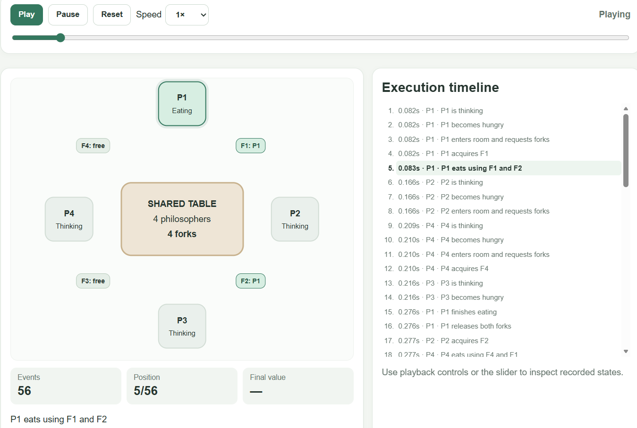

5.1.4 Dining Philosophers using a Monitor
In the above trace, the philosophers are waiting as long as any one of their neighbors is eating. Whenever a philosopher has completed his meal and has released the forks, the other philosophers who were waiting get to know about it and verify that both the forks are available.
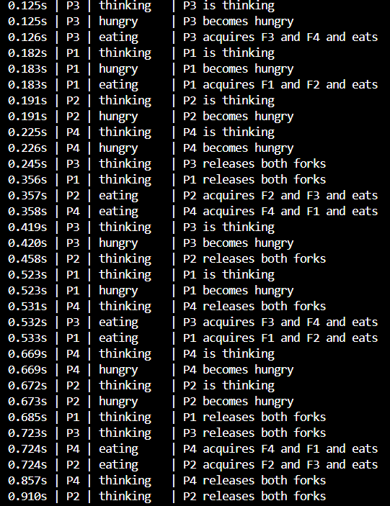
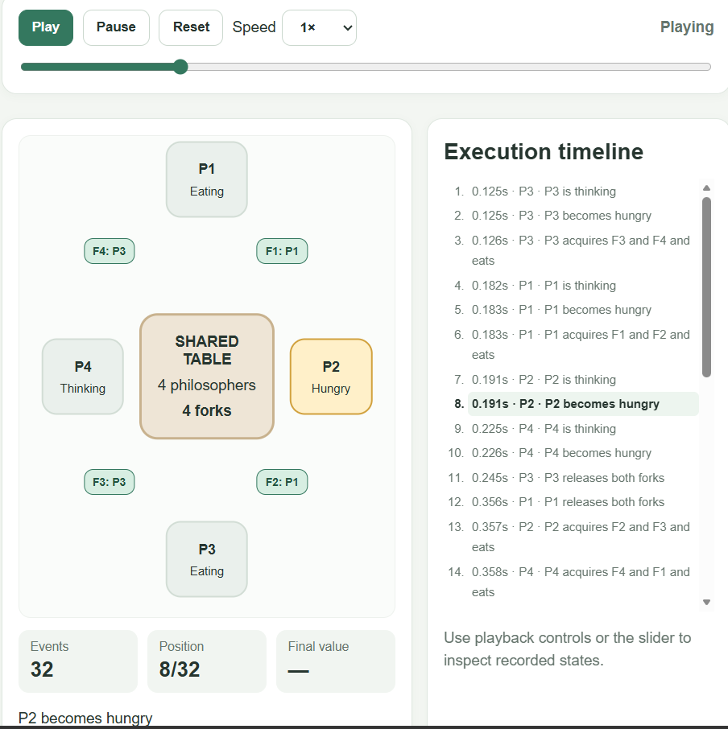

Analysis of Synchronization Methods

6.1 Race condition
A race condition is a situation where the outcome of the program is determined by the order of execution of concurrent threads. In Readers-Writers, without proper synchronization, updates to shared_value can be lost by writers. Resource semaphore or monitor synchronization mechanism prevents the writers from accessing and modifying the shared value at the same time. The reader_count_lock protects reader_count from being accessed by several readers.

6.2 Mutual exclusion
Mutual exclusion guarantees that only one thread accesses the resource that is required to be accessed exclusively. In both Readers-Writers solutions, several readers can access the shared data, however, a writer has to have the exclusive access to the data. In Dining Philosophers problem, semaphores guarantee that only one philosopher accesses a fork. Monitor guarantees that philosopher accesses both forks when the conditions for eating are met.

6.3 Deadlock
Deadlock is a situation when a thread waits infinitely for resources held by other threads. In Dining Philosophers solution using semaphores, a room semaphore limits the number of philosophers to three. It ensures that four philosophers cannot hold one fork and wait for another one. In Dining Philosophers solution using monitors, a philosopher eats only when his neighbouring philosophers do not.

6.4 Starvation
Starvation means that a thread waits too long because the resource is accessed by other threads over and over again. In readers preference semaphore solution, writers might experience starvation since more readers keep coming. Writer preference monitor minimizes the chance of starvation by preventing readers from entering while writers wait their turn. However, readers might have to wait if more writers keep coming. Both solutions for Dining Philosophers problem do not guarantee FIFO scheduling of threads and thus starvation might occur.

6.5 Concurrency and repeatability
Both programs use Python threads and synchronization to illustrate the concurrency of the threads. Since the scheduling of the threads is made by an operating system, the sequence of events can differ each time. Thus, the terminal output and HTML animation are different each time. Each HTML file reflects the sequence of events of one particular execution and not the sequence of the current execution.

Comparative Analysis of Synchronization Methods

Aspect | Semaphore-based approach | Monitor-based approach
Control mechanism | Uses explicit semaphore acquire() and release() operations to control access. | Uses shared state protected by a lock and a condition variable.
Readers–Writers | Uses a reader-count semaphore and a resource semaphore to coordinate readers and writers. | Checks the number of active readers, whether a writer is active, and whether writers are waiting before allowing access.
Dining Philosophers | Uses a room semaphore and a separate semaphore for each fork. | Checks the states of neighbouring philosophers and coordinates access to both forks under the condition lock.
Visibility of conditions | Access rules are spread across semaphore operations, so the overall logic may be harder to follow. | Entry conditions are grouped with the shared state, making the access rules easier to understand.
Deadlock strategy | Limits the number of philosophers competing for forks to three at a time. | Allows a philosopher to proceed only when both neighbouring philosophers are not eating, avoiding partial fork acquisition.
Fairness | Does not guarantee strict FIFO ordering. The Readers–Writers solution may favour readers. | Gives waiting writers priority in the Readers–Writers problem, but does not guarantee strict FIFO ordering for all threads.
Both the above-mentioned synchronization techniques can cope with the problem in question if applied appropriately. Semaphores allow controlling access to resources, whereas the monitor-based synchronization allows having all the information related to the shared state and access requirements in one place. Nevertheless, neither of the approaches will guarantee fairness without additional measures. So, for instance, in the solution to the problem using semaphores, where the preference is given to readers, a writer can have to wait for an indefinite amount of time if there is a continuous influx of readers. On the other hand, if we look at the solution based on monitors, where the priority is given to writers waiting, readers can face certain problems.

Conclusion and Future Scope
This assignment uses Readers-Writers and Dining Philosophers problems in Python through semaphores and monitor synchronizations. The four solutions provided have used concurrent threads to illustrate synchronization, protect common resources, logging of execution events and create HTML animation to view the behavior of the programs.
Using these solutions, it is possible to comprehend the significance of synchronization when there are multiple threads working on common data or resources. In case of the readers-writers problem, it is possible to see how multiple readers work with the same data simultaneously and writers need exclusive access. This problem demonstrates how synchronization affects the problem of fairness. As regards Dining Philosophers problem, the solution provided using semaphores avoids deadlock as it limits the number of philosophers trying to get forks while the other solution based on monitors restricts the philosopher to eat until the adjacent philosophers do not eat.
For future scope, the project may be improved by introducing strict FIFO scheduling, enabling users to define the number of readers, writers, philosophers and collection of statistics in order to compare the performance of different algorithms. All these should be properly tested so that synchronization constraints are preserved and event logs reflect the behavior of programs.

AI Assistance and Development Record
AI assistance was used during development to help design and explain synchronization code, troubleshoot generated HTML playback, improve the visual layout, and organize the report. The student must review this summary and add the exact tools/models and prompts used during the work.

9.1 Prompts and changes to document

9.1.1 Initial prompts
"Implement readers writers problem in python using semaphore. Use multiple reader and writer threads and explain how synchronization is working."
"Now do the same readers writers problem using monitor. use condition variable and make sure multiple readers can read but writer should get exclusive access."
"Implement dining philosophers problem for 4 philosophers and 4 chopsticks using semaphore in python. How can we prevent deadlock?"
"Can we use a counting semaphore as a room and also queue to prevent starvation? give me the code in one file."
"Now implement dining philosophers using monitor also. Philosopher should eat only when both left and right chopsticks are available."

9.1.2 Follow-up prompts
"I want to show the execution in html with animation so that we can see how philosophers and readers writers are working. How can we do this?"
"Create html animation for all four programs and show the states of threads and when they are waiting, reading, writing or eating."
"The html page is opening but events are not showing properly. check the playback logic and fix it."
"Make the animation look better and add play pause reset and speed control."
"The animation should use the events recorded from python program, not just show a random animation."

9.1.3. Student Modifications
During development, some changes were made to make the program output easier to understand. The thread names and event messages were adjusted so that it was easier to identify which reader, writer, or philosopher was performing an action. The delay between thread operations was also adjusted to make the execution easier to observe.
Some changes were made to the HTML animation to improve how the recorded events were displayed. The playback controls and timeline were arranged to make it easier to follow the execution step by step. The event display was also checked after correcting the issue where the recorded events were not appearing properly.
The code was organized into separate files for the semaphore-based and monitor-based solutions, making each implementation easier to run and compare. The generated HTML pages were then used to observe the different synchronization behaviours.

References
[1] Python Software Foundation, “threading — Thread-based parallelism,” Python 3 Documentation. Available: https://docs.python.org/3/library/threading.html
[2] Python Software Foundation, “Semaphore Objects,” Python 3 Documentation. Available: https://docs.python.org/3/library/threading.html#semaphore-objects
[3] C. A. R. Hoare, “Monitors: An Operating System Structuring Concept,” Communications of the ACM, vol. 17, no. 10, pp. 549–557, Oct. 1974. doi: https://doi.org/10.1145/355620.361161
[4] Oracle — Guarded Blocks Explains how threads wait for conditions and check them again after waking up. Link: https://docs.oracle.com/javase/tutorial/essential/concurrency/guardmeth.html
[5] University of Cambridge — Operating Systems: Concurrency Lecture materials and explanations of operating system concurrency concepts. Link: https://www.cl.cam.ac.uk/teaching/
[6] R. H. Arpaci-Dusseau and A. C. Arpaci-Dusseau, “Common Concurrency Problems,” in Operating Systems: Three Easy Pieces. [Online]. Available: https://pages.cs.wisc.edu/~remzi/OSTEP/
[7] Oracle, “Synchronization,” The Java Tutorials. [Online]. Available: https://docs.oracle.com/javase/tutorial/essential/concurrency/sync.html

Academic-Integrity Declaration
“I declare that I have personally tested and understood the submitted programs. I have disclosed the AI tools and external resources used in developing this assignment. I can explain the synchronization logic, generated HTML simulation, and modifications made to the code. I have not knowingly submitted another student’s work or unacknowledged third-party material as my own.”
Student: Greeshma
USN: NNM24IS087
Signature: ______________________________
Date: ______________________________

